**Installation Process in Windows:**

**1) If the system don't have Python, then install Python by down loading it from the following site.**

[**https://www.python.org/downloads/release/python-374/**](https://www.python.org/downloads/release/python-370/)

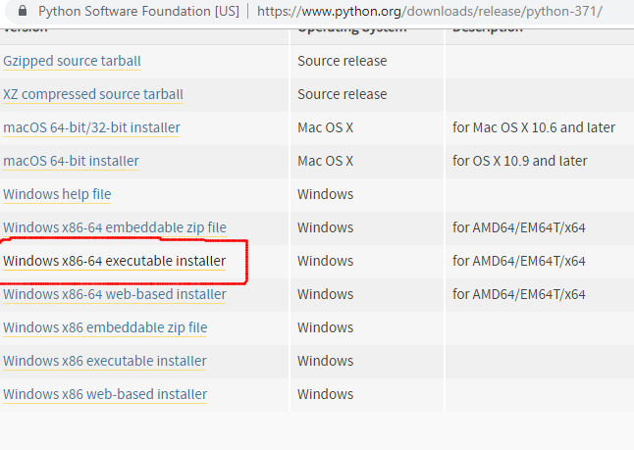**1.a) Go to the above site, come to the bottom of the page, and click on ‘ Windows x86-64 executable Installer ‘, as shown in the above figure.**

**1.b) Python Application will be downloaded into the ‘Downloads’ folder as shown in the following figure.**

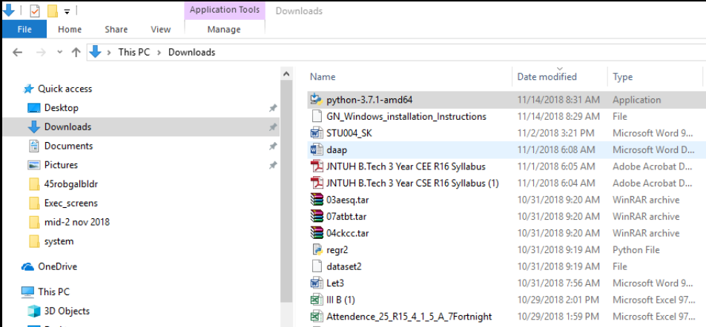

**1.c) Click on python ‘ python-3.7.1-amd64’ to get the following screen. Select both the options at the bottom of the screen, and click on “ Install Now“.**

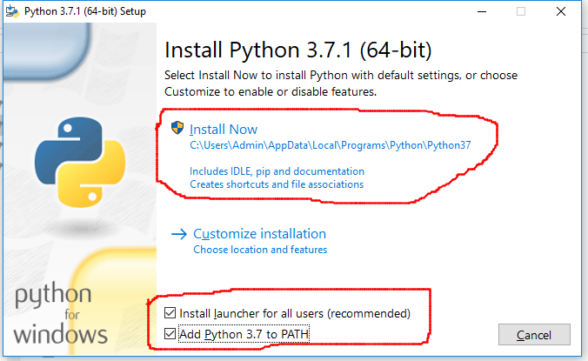

**1.d) Follow the installation process, and, finish it. After completion, open command prompt, and give the command python -V, as shown below.**

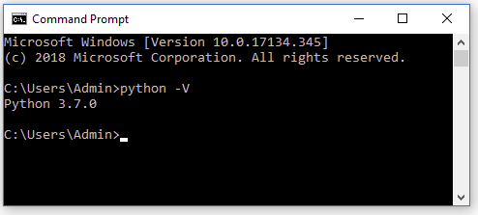

**2) Close the above command prompt, and re-open it as an administrator, as shown in the following figure.**

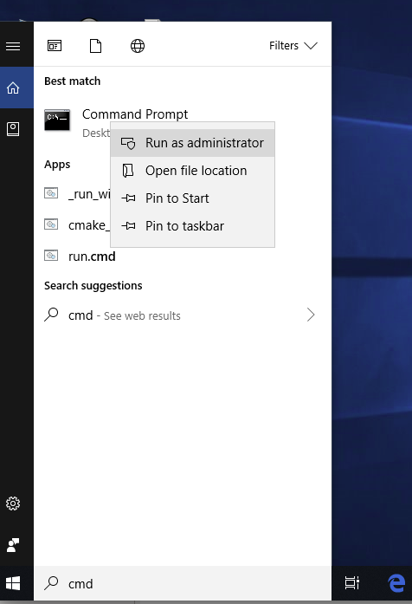

**(Note: When you RIGHT-CLICK on command prompt, the submenu will be opened. From there, you can run it as administrator.)**

**3.a)Execute the command from command prompt: pip3 install wheel. You should get the wheel successfully, installed as shown in the following figure. Otherwise, discuss with us, when we meet next time.**

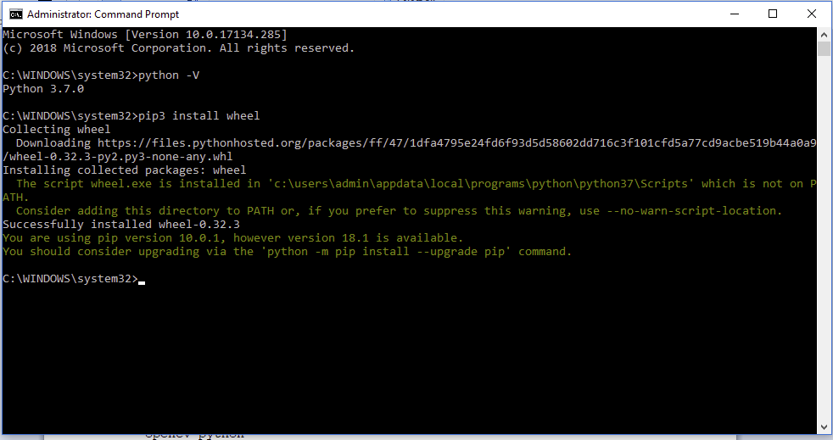

**4)Execute the command from command prompt: pip3 install pyqt5. You should get the pyqt5 successfully, installed as shown in the following two figures. Otherwise, discuss with us, when we meet next time.**

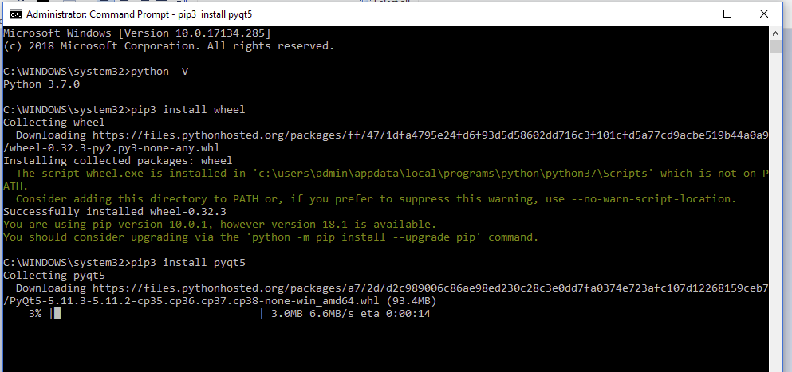

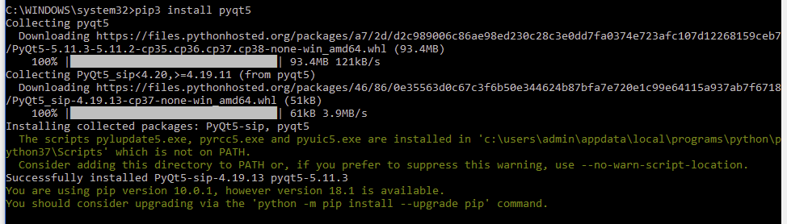

**5)Execute the command from command prompt: pip3 install pillow. You should get the pillow successfully, installed as shown in the following figure. Otherwise, discuss with us, when we meet next time.**

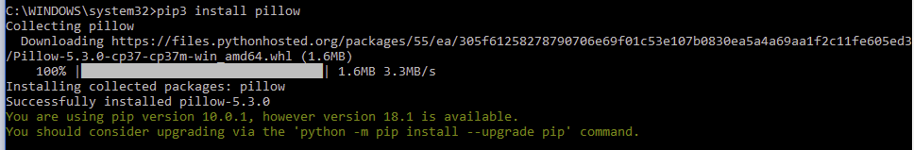

**6)Execute the command from command prompt: pip3 install opencv-python. You should get the opencv-python successfully, installed as shown in the following figure. Otherwise, discuss with us, when we meet next time.**

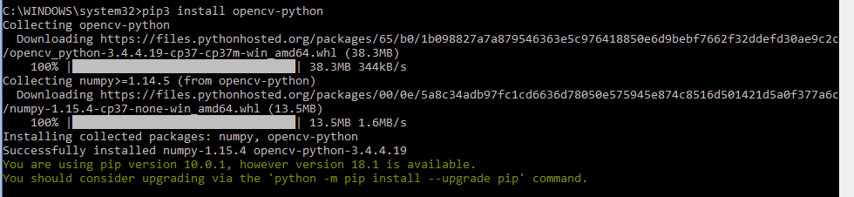

**6.a)Execute the command from command prompt(CMD): pip3 install pyqt5-dev-tools**

**7) Install sqlite by downloading it from the following site:** [**https://www.sqlite.org/download.html**](https://www.sqlite.org/download.html)**. Open this site, go to the bottom, and click on “sqlite-tools-win32-x86-32--------.zip”, as shown in the following figure.**

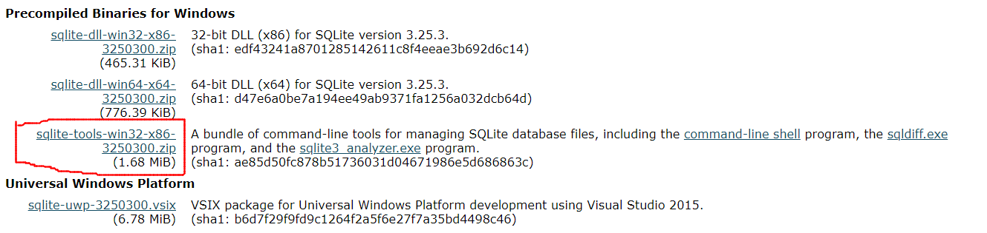

**7.a). The sqlite tools, will be downloaded into your downloads folder, as shown in the following figure.**

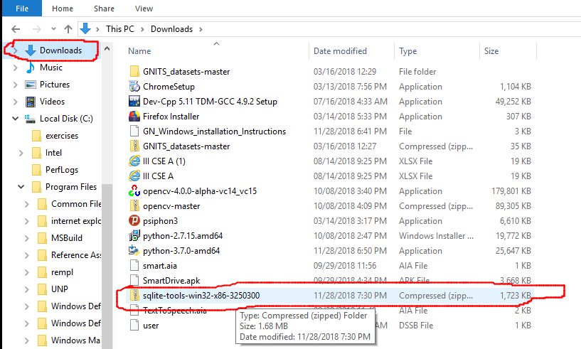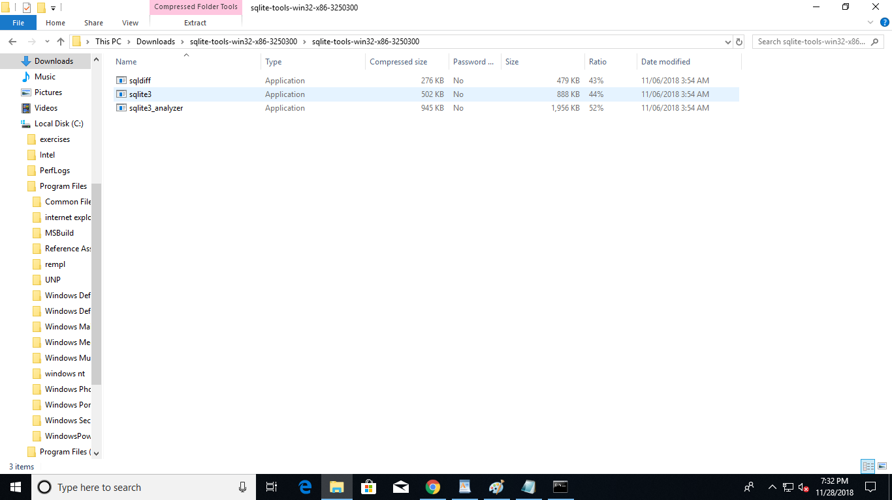

**7.b) Extract the three files in this compressed file, into a separate folder, and RIGHT CLICK on ‘ sqlite3 ‘ as shown in the following figure.**

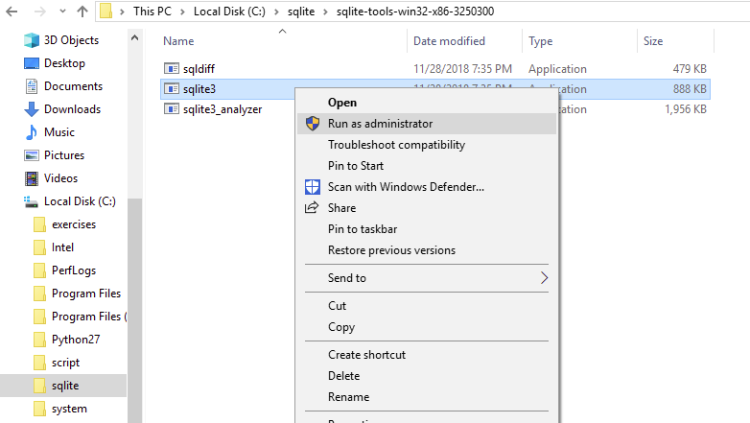

**7.c) You are likley to get a message, as shown in the following figure.**

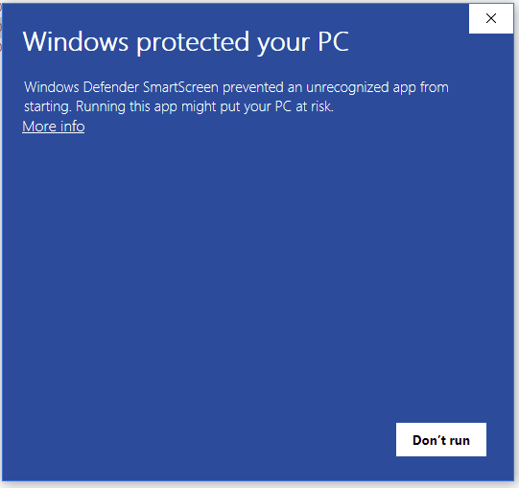

**7.d) Click on ‘More info’, if you get the above message. Click on ‘ Run anyway’ as shown in the following figure.**

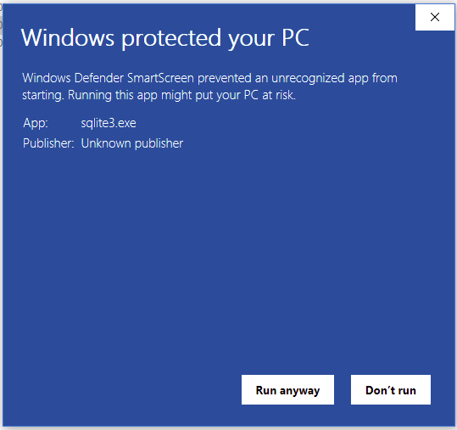

**7.e) You should get a screen as shown below.**

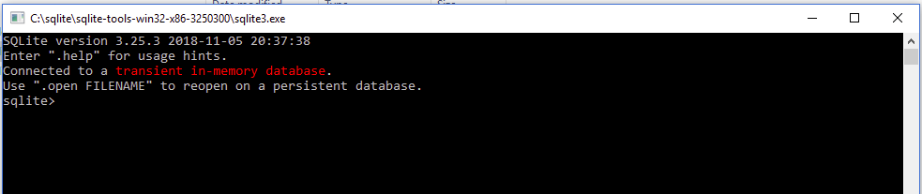

**7.f) Give the command .system dir/p as shown in the below figure. It should display the current directory structure.**

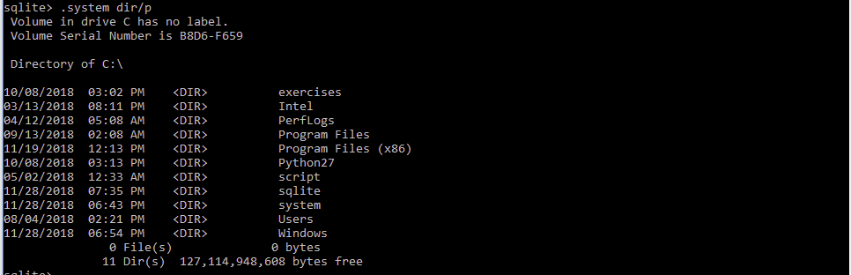

**7. g) You can give the command .cd .. to move one level up in the directory. Like wise, .cd ../.. can move you two levels up.**

**8). Open windows explorer, and search for ‘Designer’. This search will take a few minutes. Find out whether you have Anaconda’s designer, as shown in below figures.**

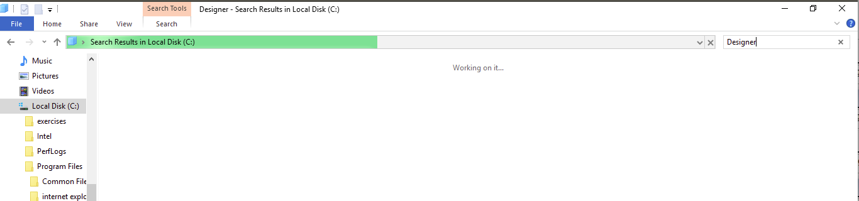

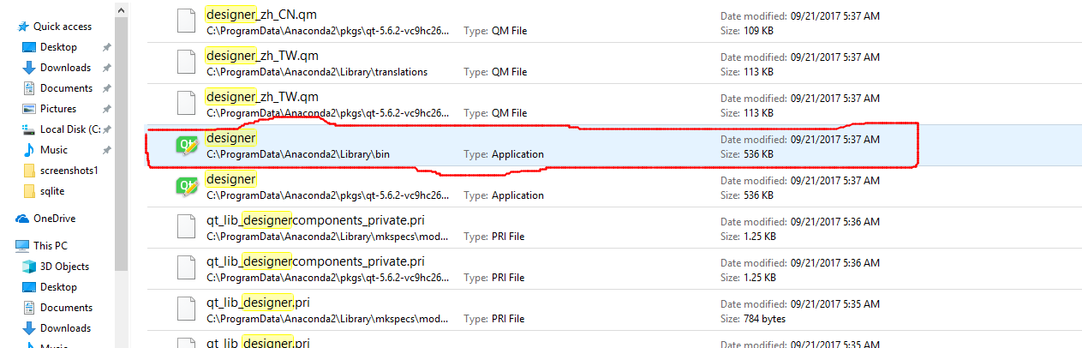

**8. a) If you have the designer, as shown in the above figure. Remember it’s path(Take a screen shot on your mobile), as you have to use this designer many times in your project.**

**8.b). Click on the above designer. You should get the following.**

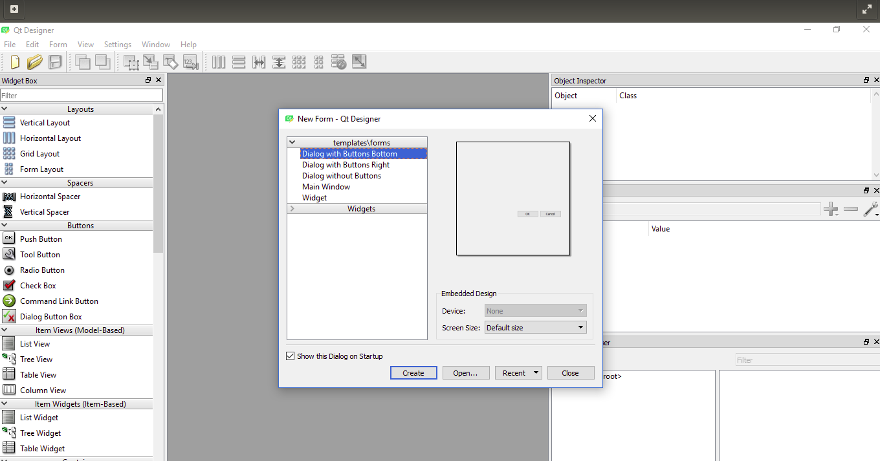

**8.c) If you are able to get the above, then you can ignore the remaining steps in this document.**

**8.d) If you are not able to get the above, then the Anacondas Designer is not successfully installed on your system. If you have Anaconda, on your system, remove it, and reinstall it as explained below.**

**8.e) install Anaconda by downloading it from:** [**https://www.anaconda.com/download/**](https://www.anaconda.com/download/)**. Click the Download button, under Python 2.7 version as shown below.**

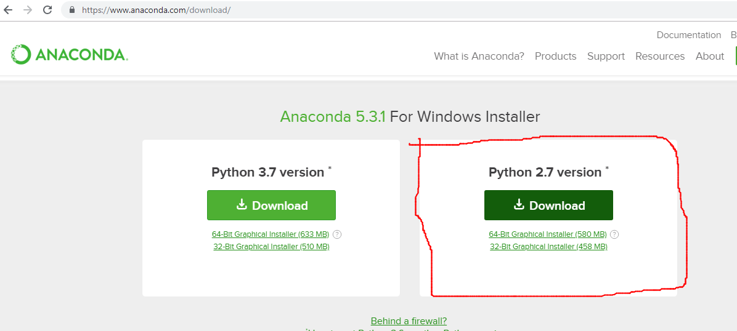

**8.f) If you get any cheat sheet, as shown below, fill in the details with your e-mail ID etc.**



**8.g) Anaconda application will be downloaded into your Downloads, as shown below.**

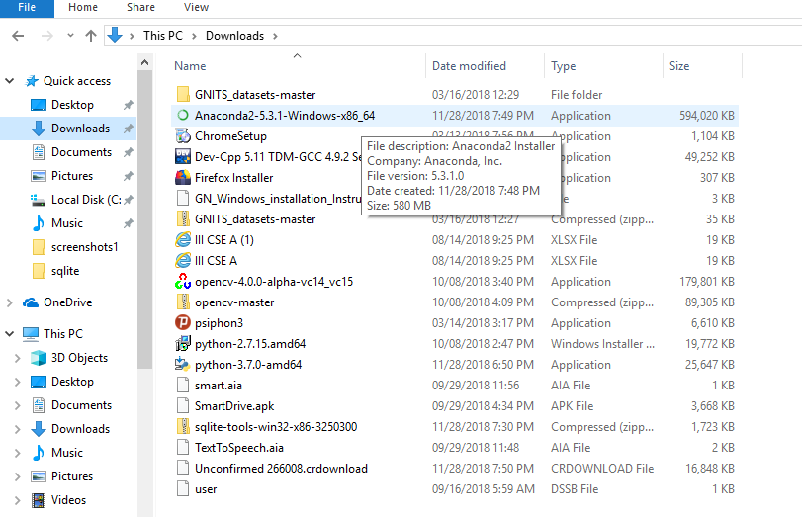

**8.h) By clicking on this Anaconda application, it will start installing as shown in the below figure.**

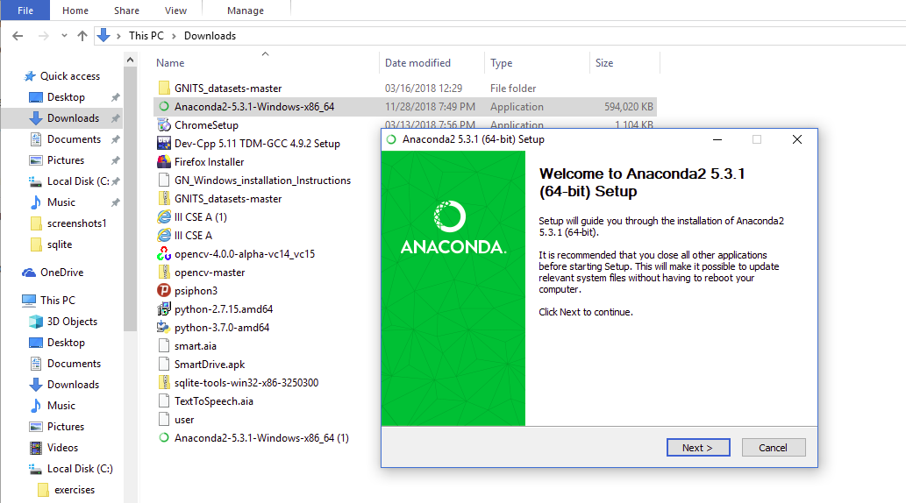

**8.i) Proceed with Anaconda’s installation by clicking on the ‘Next’ and selecting ‘All users’ as shown below.**

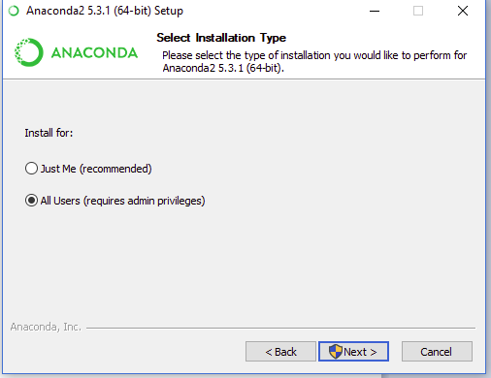

**8.j) Proceed with the installation, by choosing a folder for installation, as shown below.**

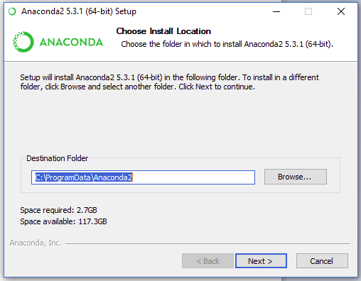

**8.k) You need not choose any Advanced options, and, leave them blank, as shown below.**

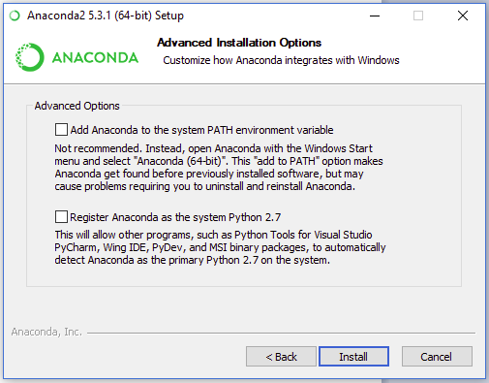

**8.l) Following screen appears, while installation being progressed.**

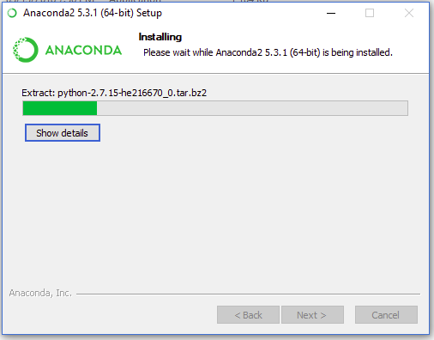

**8.m) You can choose ‘skip’ option, when the following screen is displayed.**

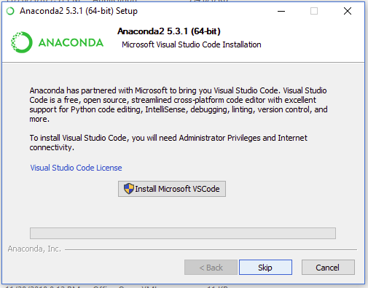

**8.n) Anaconda’s installation can be finished, by clicking the ‘Finish’ Button.**

**8.o) After Installation is finished, open windows explorer, and, repeat steps, 8, 8.a,8.b & 8.c**